Please return by e-mail to admissions@queens.cam.ac.uk by Thursday 26 August 2021

Memorandum of Understanding

The offer of a place to study at Queens’ College Cambridge is a privilege sought after by many talented students, and one that confers lifelong benefits. With this privilege comes responsibility. By coming into residence you are accepting certain academic and community-based requirements that will apply throughout your undergraduate career.

The College expects you to work to the best of your ability in order to fulfil your academic potential. We expect you to attend lectures, Supervisions, and other teaching and learning exercises as advised by your Director of Studies, to submit all requisite academic work on time and to the best of your ability, and to strive towards excellence in all your academic endeavours.

We require you to prioritize your academic commitments above your leisure activities. Failure to attend scheduled teaching and learning exercises, failure to submit the work required of you, or failure in University examinations may be found to constitute ‘neglect of studies’. Undergraduates who are found to have been in persistent neglect of their studies are liable to disciplinary sanctions under College Regulations and may be required to withdraw from the University.

We also require you to adhere to the College’s published health guidance and join in the collective efforts to create a safe environment in which to live and study. This includes a willingness to follow guidance from Public Health England, the University of Cambridge and the College. Serious and persistent breaking of this guidance will be dealt with under College disciplinary procedures and may result in people being required to leave College accommodation or prevented from entering college property.

You are requested to sign this document before coming in to residence, in order to confirm that you understand it and will strive to carry out the academic responsibilities that you undertake by accepting a place as an undergraduate at Queens’ College.

Signed, on behalf of the College | Signed:
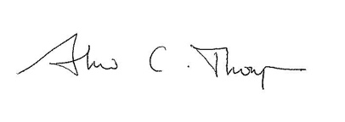
Dr Andrew Thompson | Print Name:
Senior Tutor | Prospective undergraduate in: (state subject of study)
10 August 2021 | Date:

